Project 6
CS 557 - Computer Graphics Shaders
Name: Tianle Yuan (933-946-576)
Project Number: 6
Project Name: The Cat Menagerie
Video Link: https://media.oregonstate.edu/media/t/1_swl66nts
Email: yuant@oregonstate.edu
Time: February 25, 2020

What I did:
I did the typical NPR stylization named Cartoon stylizing and I also did some Cartoon effect for a famous manga named Naruto. Basically, there are three steps that I did:
1. Silhouette Extraction.
2. Light Effect Discreteness.
3. Art Processing.
How do I did:
Step 1 Silhouette Extraction：For this part, I did two experiment for two ways.
The first way is using the geometry shader for dot product comparison between each two faces, which can be seen as below:
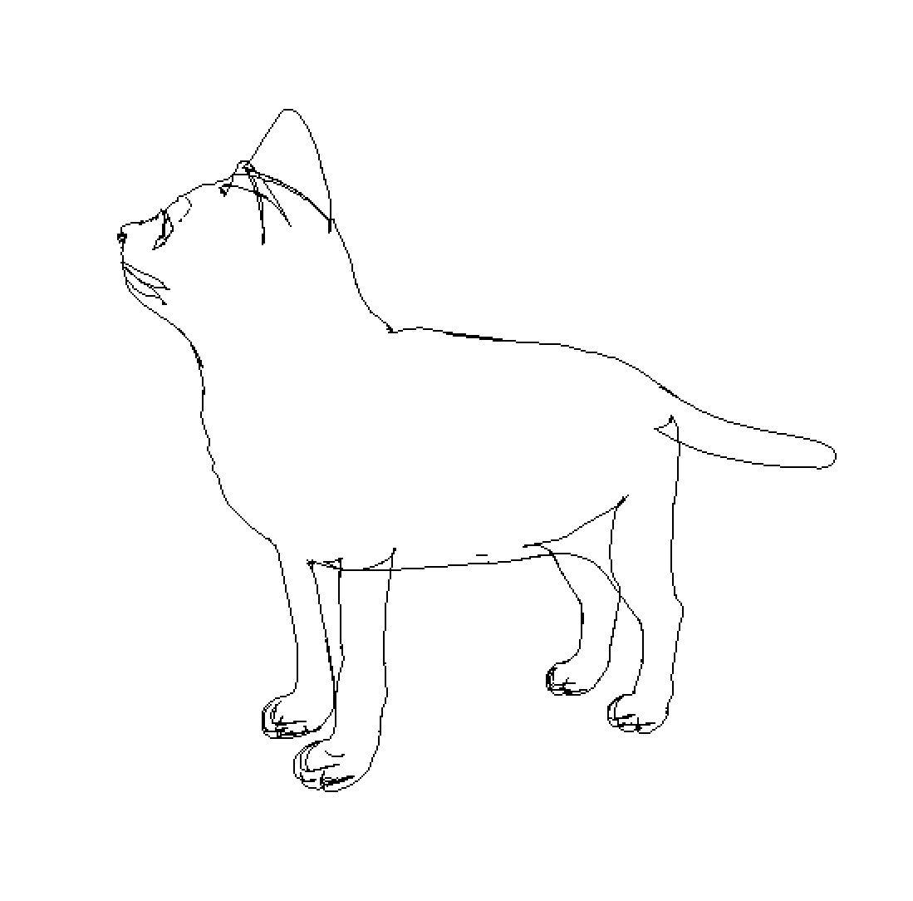
The second way is directly compare the dot product result in the fragment shader for each pixel in the scene, which can be seen as below:
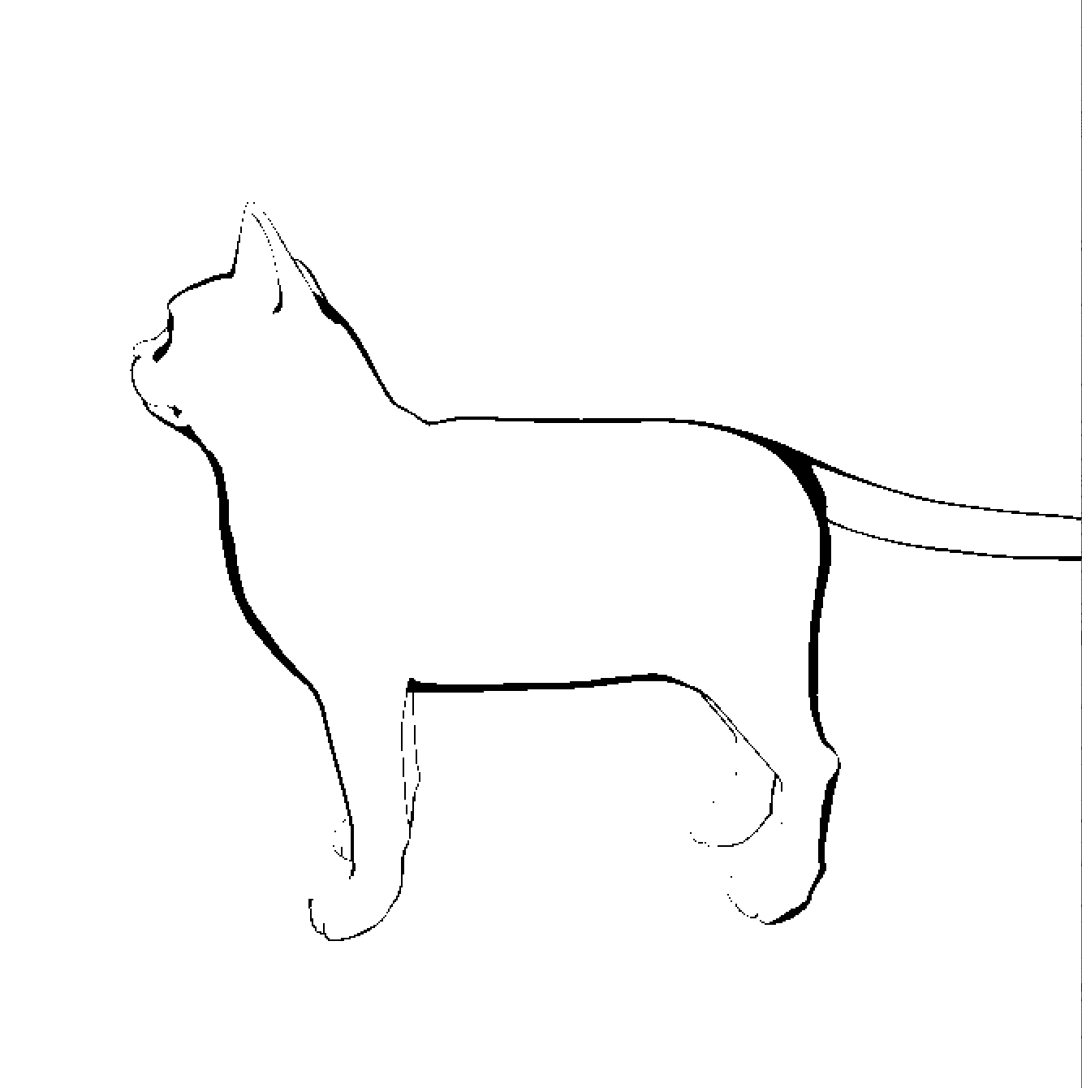
Obviously, I will chose the second way for the Silhouette drawing for the smoother and thicker contours.

Step 2. Light Effect Discreteness：

I did this by setting the discrete threshold for the dot product between light and the normal.

float df = dot(Normal, Light);
if (df < 0.1)
df = 0.0;
else if (df < 0.2)
df = 0.2;
else if (df < 0.4)
df = 0.4;
else if (df < 0.6)
df = 0.6;
else if (df < 0.8)
df = 0.8;
Else
df = 1.0;

The result can be seen as below:

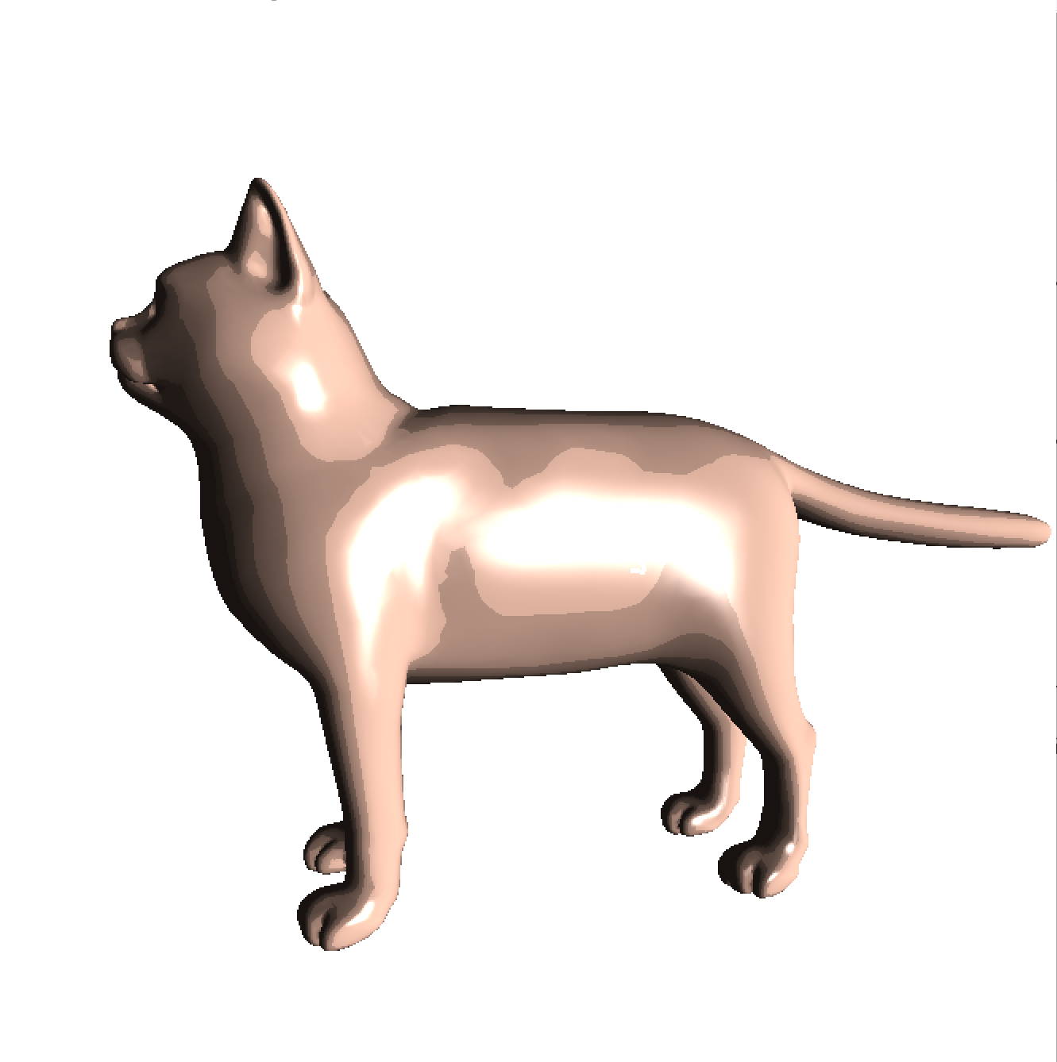

Step 3. Art Processing：

At this time, we combine the effect of the silhouette with the discrete lighted surface, then we get:
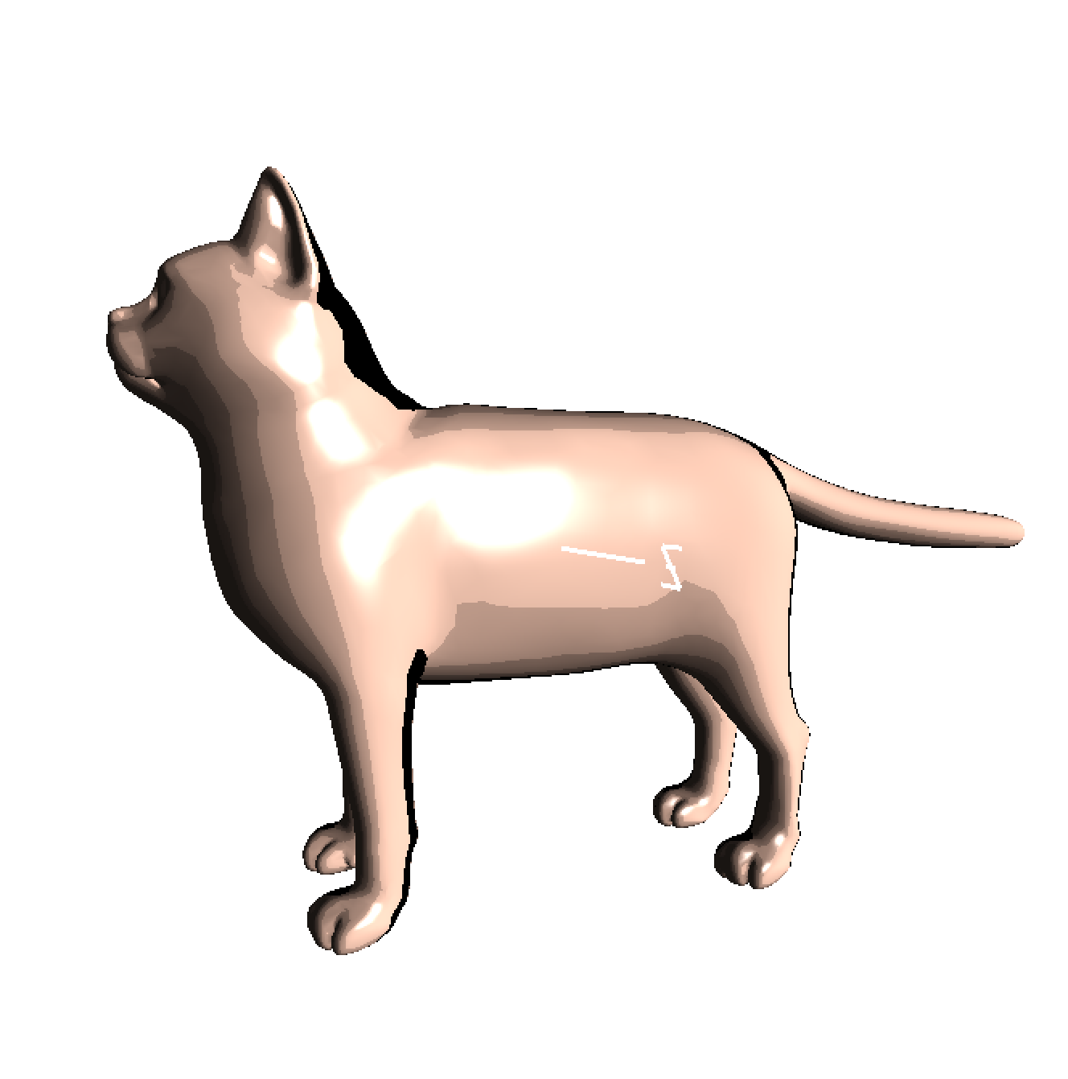

Finally, we give the cat with a transparent cover by draw a new cat whose vertices is increased in the direction on the normal. The final result can be seen as below:

